Subject: Information for ICCT2018 Authors and Participants

Dear Participants,

Please read the follow information for your meaningful and successful participation. We thank you for your active participation and cooperation.

Program and schedule of ICCT2018 will be posted on the “program” menu at ICCT2018 official site (http://icct.iacst.org) from November 5. There are 3 types of presentation – oral, poster, and video presentation. Please find your presentation type, session name and time for the preparation of your presentation, consulting the following information.

A. Submission of Copyright Form
If not submitted yet, please sign the attached copyright-form for each accepted paper and send it to the official mail address at icct@iacst.org by November 10, 2018. Submission of the copyright form is needed for all types of presentation.

B. Paper Presentation
[1] Preparation for oral presentation
There are fourteen oral presentation sessions (session FR1 to FR7, session ST1 to ST7). Authors of FR oral-presentation must present their papers at Zhijiang College of Zhejiang University of Technology on November 16 and ST papers at Yuexiu University on November 17. In each presentation, a presentation must be done in 18 minutes including 12 minutes of presentation and another 6 minutes of Q&A. Authors must prepare their presentation slides and prepare them before presentation time. Best and Excellent paper awards will be given before the Banquet dinner, based on presentation evaluation scores.

[2] Preparation for poster presentation
There is one poster-presentation session (session ST-P) on November 17 in Yuanpei College. Please check the exact session place and time at “program” menu of the official site. An A0-size (841x1189mm) white paper is prepared for each poster presentation. Posters must be prepared between 08:40 and 09:10 on November 17.

C. Venue for Events
Since we have three events – ICCT2018, CADI2018, and ISCC 2018 together, please note that we will be using several places for each main event or ceremony. While ICCT2018 opening ceremony will be held in Zhijiang College of Zhejiang University of Technology in November 16, CADI/ISCC2018 opening ceremony will be held in Yuanpei College in November 17. You can find the exact place and room numbers for each program on the program menu of the official website (http://icct.iacst.org). Awarding and Chinese traditional performance are prepared at the Banquet.

D. Paper Recommendation to SCOPUS/SCIE journals
Just after the ICCT2018 is finished, papers selected by the program committee will be recommended to SCOPUS indexed journals. We will mail soon specific information for publication procedure to the corresponding authors.

E. Accommodation and Payment
For accommodation, we booked your rooms in the 5-star rated Mirrorlake Hotel (http://www. mirrorlakehotel.com, Keyan scenic spot, Shaoxing, China). It is more convenient to stay in the Mirrorlake hotel for the ease of transfer and low accommodation cost. Room price is 340 Chinese yuan, which is government supported discounted price, and you are supposed to pay on your check-in date by yourself. If you don't have your room booked yet, please contact IACST office at icct@iacst.org.

F. Visiting a Representative Local Company (Jinggong Holding Group)
Jinggong Holding group is the biggest company based in Shaoxing City. We prepared a tour program to Jinggong company facilities including high-tech industrial robot making and yellow wine producing. Tour will start 14:50 on November 15 from the Mirrorlake Hotel lobby and it will take about three hours. For those who want to join the tour, please reply to icct@iacst.org for your participation. Prior reservation is necessary for bus preparation.

G. Transportation
Please refer the following transportation plan:

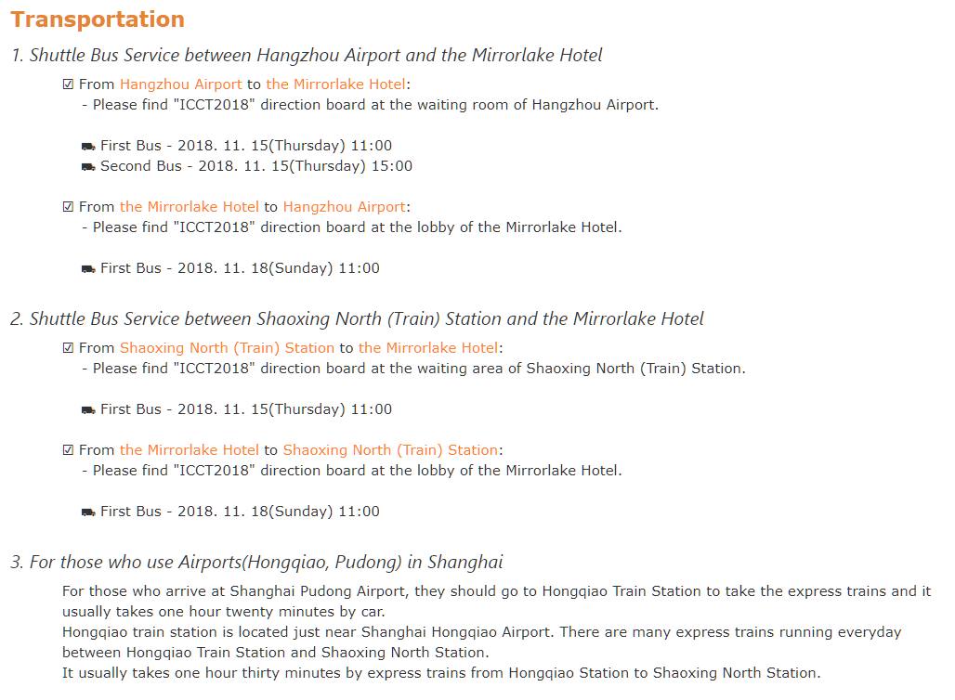

The ICCT2018 Program Committee

* Appendix A. Schedule

* Appendix A. Schedule
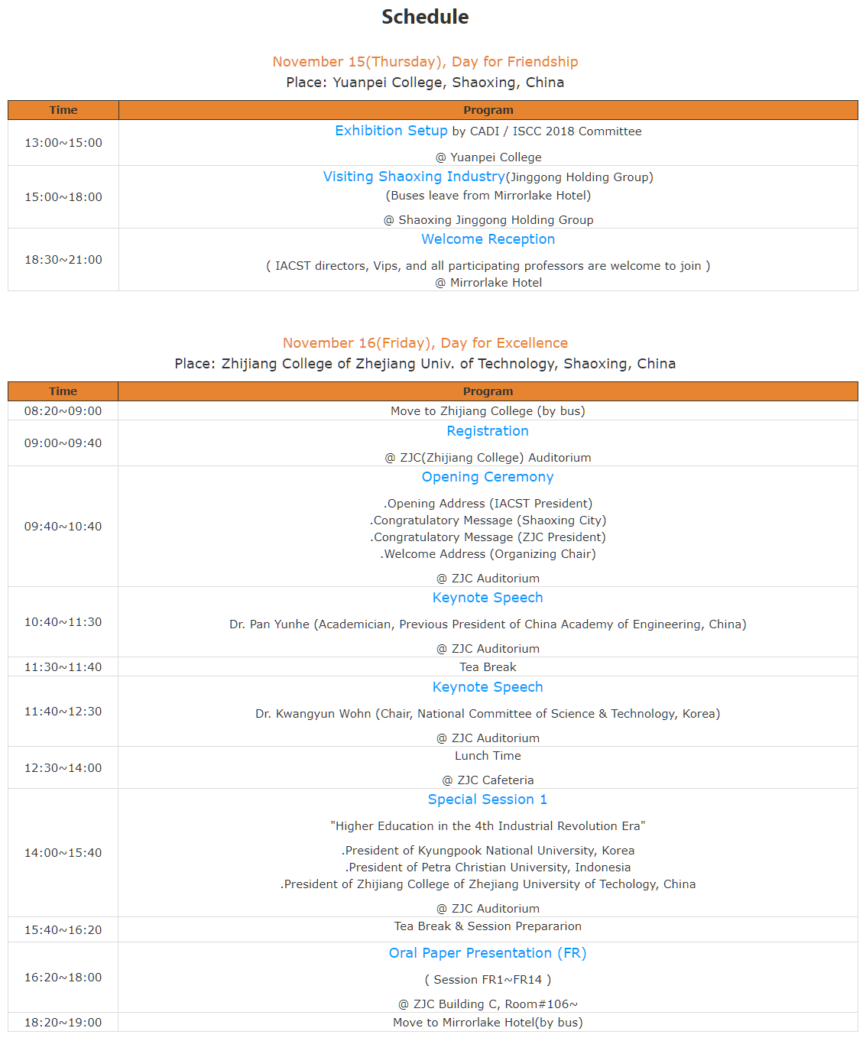

(http://icct.iacst.org)
